- In Eclipse, select “File -> Import -> Projects from Folder or Archive” to import the demo1 folder.

This will create a standard Java project with the two source files in the default package. Now we will convert them into Maven project first.

- Right click on the “demo1” project, select “Configure -> Convert to Maven Project”

Afterward, you should see a new “pom.xml” appear in the structure, as well as a “bin” and “target” folder. At this point this is already a Maven project, but now let’s do a little more adjustments to adhere to the standard Maven directory structure.

Full layout is explained here: https://maven.apache.org/guides/introduction/introduction-to-the-standard-directory-layout.html

For us, the most important ones are:
src/main/java
src/main/resources
src/test/java
src/test/resources

- Copied from the answer here: https://stackoverflow.com/questions/35953934/directory-structure-after-converting-a-project-to-maven-in-eclipse

- Right click the project and select Properties
- Select Java Build Path/Source
- Delete all entries
- Add the standard Maven paths (src/main/java, src/main/resources, /src/test/java and src/test/resources)
Exit the Properties dialog and a Project/clean should compile everything correctly.
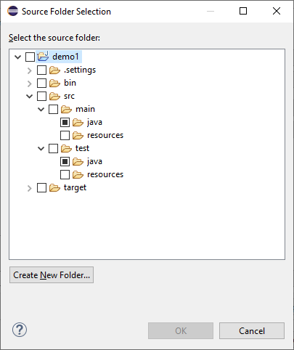

When you are done creating the new folders, select the two “java” folders and click OK.

- Now, your project tree should look something like this:
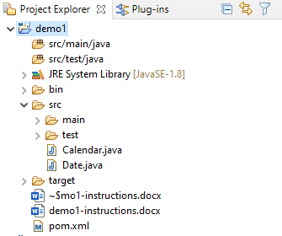
Drag the two “java” files from the “src” folder below into the “src/main/java” source folder.

- Now we’ll configure the project to be able to run with Junit5. In pom.xml, add the following dependencies block below and outside of the <build></build> block:

<dependencies>
<dependency>
<groupId>org.junit.jupiter</groupId>
<artifactId>junit-jupiter</artifactId>
<version>5.6.2</version>
<scope>test</scope>
</dependency>
</dependencies>

Also, delete or comment (use <!-- --!> for xml commenting) the line of <sourceDirectory>src</sourceDirectory> if it’s in pom.xml

Save it. And the project should be rebuilding itself at this point. If not, or if you want to be safe, I recommend selecting “Project -> Clean” then check that you are cleaning “demo1” only. (You may clean the others if you want but that might take a lot longer because of the checkstyle projects we have.)

Once the cleaning is done, right click on the project, select “Maven -> Update Project”.

- Now you should be able to write Junit5 tests in the src/test/java folder. Follow the lecture to learn how to do so.

For reference, here’s the Junit 5 guide: https://junit.org/junit5/docs/current/user-guide/

